***ASSIGNMENT#03***

***WAQAS ASHIQ***

***BCS-FA11-201***

***SECTION-C***

***EXERCISE #1:***

#include<stdio.h>

int main(void)

{

int number;

number=1;

do{

printf("%d\t", number);

number++;

}

while(number<=10);

}

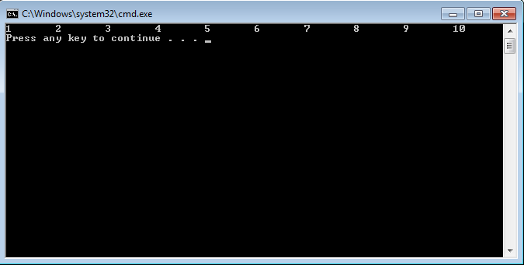

***EXERCISE#2***

#include <stdio.h>

int main()

{

int a;

int b;

int c;

for ( a = 1; a <= 10; a++ ) {

for ( b = 1; b <= a; b++ ) {

printf( "*" );

}

printf( "\n" );

}

printf( "\n" );

for ( a= 10; a >= 1; a-- ) {

for ( b = 1; b <= a; b++ ) {

printf( "*" );

}

printf( "\n" );

}

printf( "\n" );

for ( a = 10; a >= 1; a-- ) {

for ( c = 1; c <= 10 - a; c++ ) {

printf( " " );

}

for ( b = 1; b <= a; b++ ) {

printf( "*" );

}

printf("\n");

}

printf( "\n" );

for ( a = 1; a <= 10; a++ ) {

for ( c= 1;c <= 10 - a; c++ ) {

printf( " " );

}

for ( b = 1; b <= a; b++ ) {

printf( "*" );

}

printf( "\n" );

}

printf( "\n" );

return 0;

}

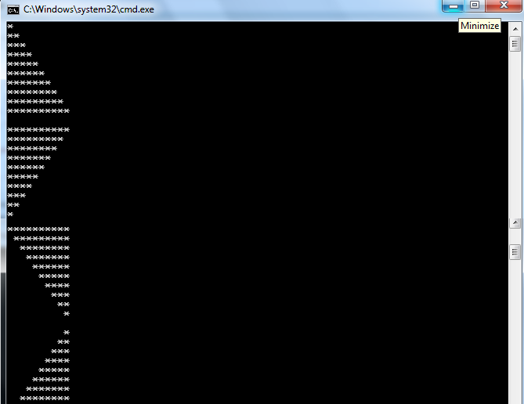

***EXERCISE #3***

#include <stdio.h>

int main( void )

{

int a;

int b;

int c;

for ( a = 1; a <= 9; a += 2 ) {

for ( b = ( 9 - a ) / 2; b > 0; b-- ){

printf( " " );

}

for ( c = 1; c <= a; c++ ){

printf( "*" );

}

printf( "\n" );

}

for ( a = 7; a >= 0; a -= 2 ){

for ( b = ( 9 - z ) / 2; b > 0; b-- ) {

printf( " " );

}

for ( c = 1; c <= a; c++ ) {

printf( "*" );

return 0;

}

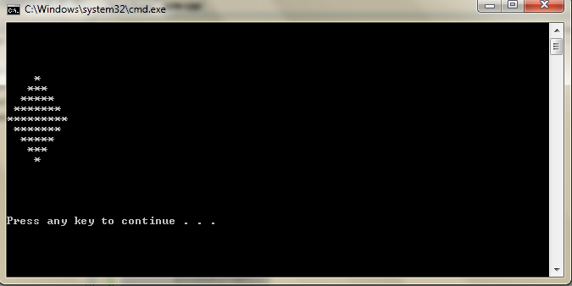

***EXERCISE #4***

#include <stdio.h>

int main( void )

{

int product;

int quantity;

double total = 0.0;

printf( "Enter pairs of item numbers and quantities.\n");

printf( "Enter -1 for the item number to end input.\n" );

scanf( "%d", &product );

while ( product != -1 ) {

scanf( "%d", &quantity );

switch ( product ) {

case 1:

total += quantity * 2.98;

break;

case 2:

total += quantity * 4.50;

break;

case 3:

total += quantity * 9.98;

break;

case 4:

total += quantity * 4.4;

break;

case 5:

total += quantity * 6.87;

break;

default:

printf( "Invalid product code: %d\n", product );

printf( " Quantity: %d\n", quantity );

}

scanf("%d",&product);

}

printf( "The total retail value was: %.2f\n", total );

return 0;

}

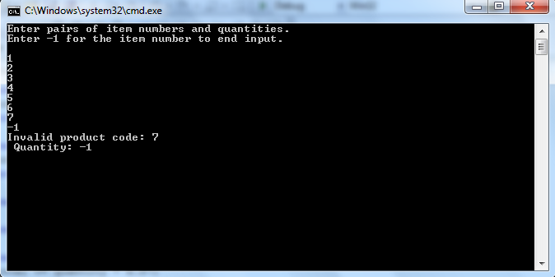

*FLOWCHART:*

Product

Quantity

Switch

5 CASES

Total value=31.71

END POINT

***EXERCISE #5:***

#include<stdio.h>

int main(void)

{

int counter;

printf("enter number of values to be add=");

scanf("%d", &counter);

int value;

int sum;

sum=0;

int a=1;

for(a; a<=counter; a++)

{

printf("enter the value=");

scanf("%d", &value);

sum=sum+value;

}

printf("sum = %d\n", sum);

}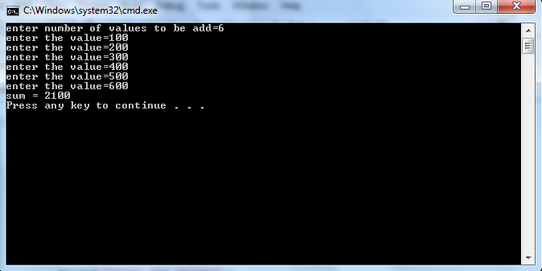

**FLOWCHART:**

INATILIZ-ATION

Int sum;

CONDITION

BODY OF FUNCTION